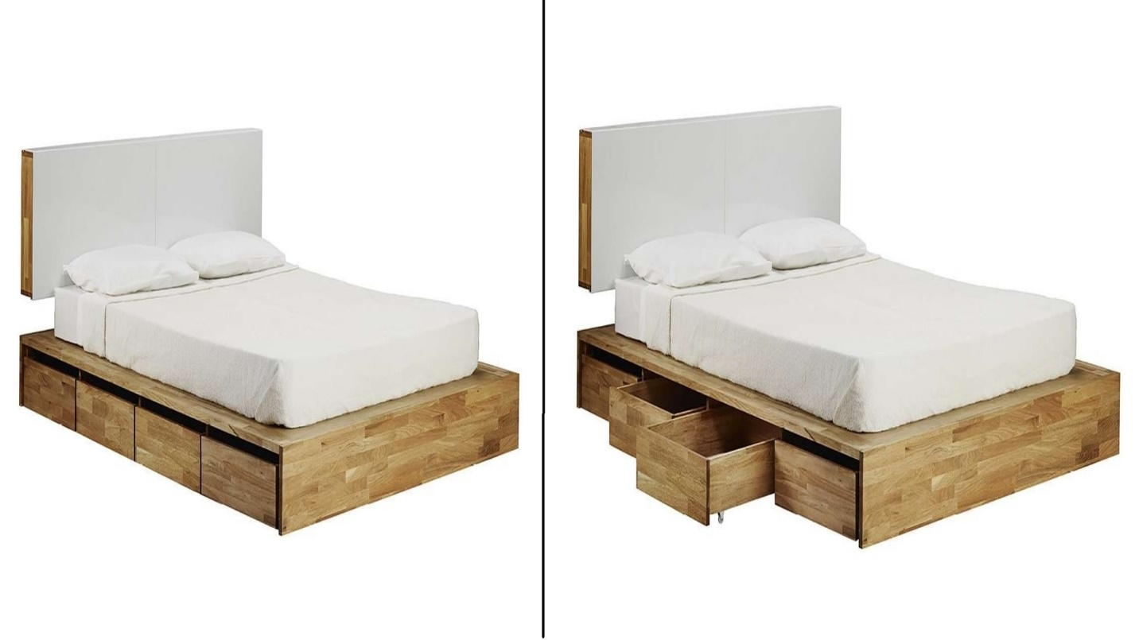

|  |  |
| --- | --- |
| **Title** | Headboard Storage Platform Bed |
| **Size** | 2.2 m long ; 2.0 m wide; 1.9 high |
| **Weight** | 131 kg |
| **Price** | $1,000.00 |